**Convolution Layer — The Kernel**

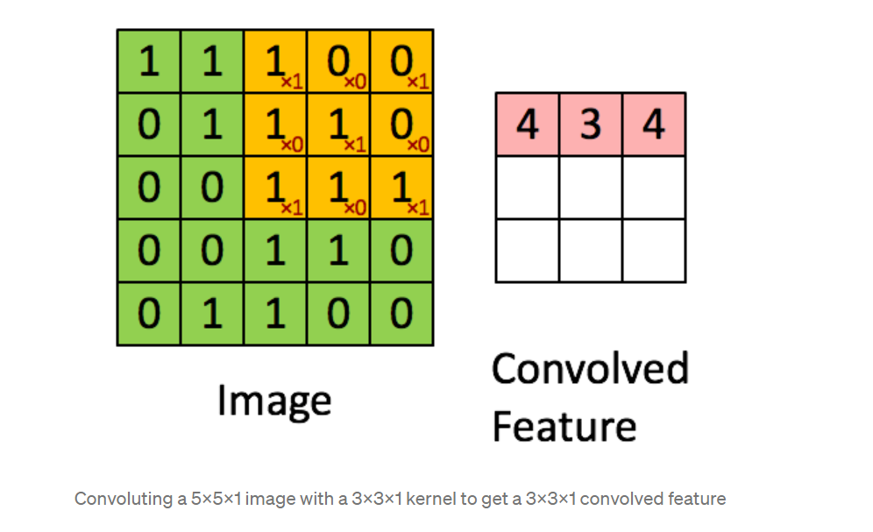 Image Dimensions = 5 (Height) x 5 (Breadth) x 1 (Number of channels, eg. RGB)

In the above demonstration, the green section resembles our 5x5x1 input image, I. The element involved in the convolution operation in the first part of a Convolutional Layer is called the Kernel/Filter, K, represented in color yellow. We have selected K as a 3x3x1 matrix. 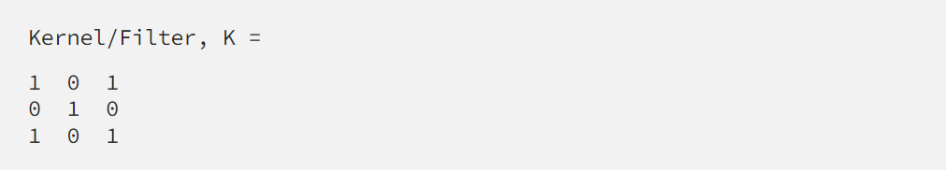

The Kernel shifts 9 times because of Stride Length = 1 (Non-Strided), every time performing an elementwise multiplication operation between K and the portion P of the image over which the kernel is hovering. 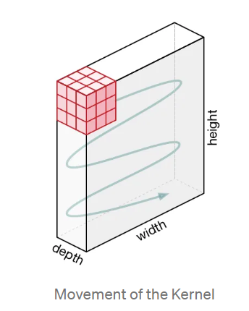

The filter moves to the right with a certain Stride Value till it parses the complete width. Moving on, it hops down to the beginning (left) of the image with the same Stride Value and repeats the process until the entire image is traversed. 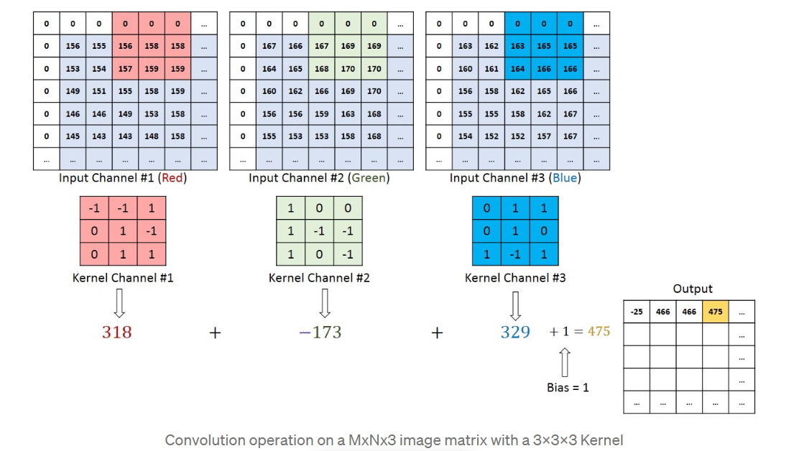

In the case of images with multiple channels (e.g. RGB), the Kernel has the same depth as that of the input image. Matrix Multiplication is performed between Kn and In stack ([K1, I1]; [K2, I2]; [K3, I3]) and all the results are summed with the bias to give us a squashed one-depth channel Convoluted Feature Output. 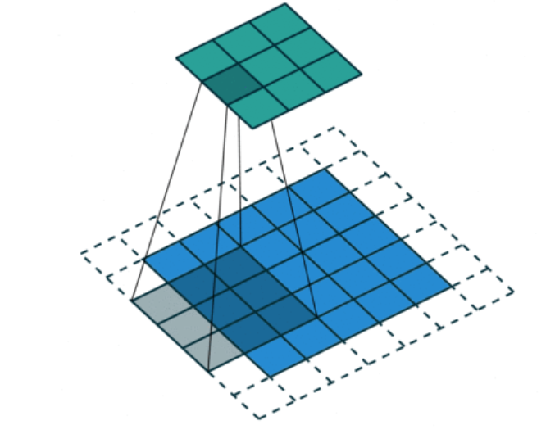 The objective of the Convolution Operation is to extract the high-level features such as edges, from the input image. ConvNets need not be limited to only one Convolutional Layer. Conventionally, the first ConvLayer is responsible for capturing the Low-Level features such as edges, color, gradient orientation, etc. With added layers, the architecture adapts to the High-Level features as well, giving us a network that has a wholesome understanding of images in the dataset, similar to how we would.

There are two types of results to the operation — one in which the convolved feature is reduced in dimensionality as compared to the input, and the other in which the dimensionality is either increased or remains the same. This is done by applying Valid Padding in the case of the former, or Same Padding in the case of the latter. 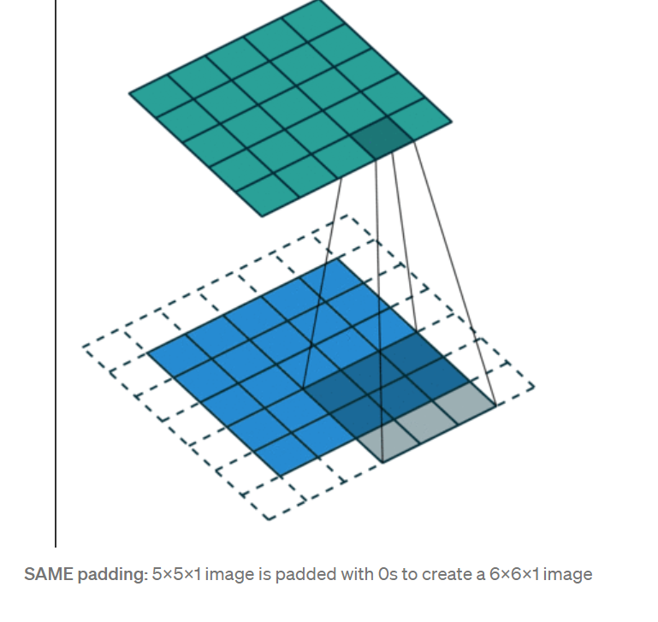

When we augment the 5x5x1 image into a 6x6x1 image and then apply the 3x3x1 kernel over it, we find that the convolved matrix turns out to be of dimensions 5x5x1. Hence the name — Same Padding.

On the other hand, if we perform the same operation without padding, we are presented with a matrix that has dimensions of the Kernel (3x3x1) itself — Valid Padding.